_________ ____________
Student ID Student Name

Lab 1: Familiarization with the IDE and C++ Programming
Objective of Experiment: Introduction of DEV C++ IDE and Programming Environment

Goals: Students will be able to understand the DEV C++ IDE and Programming Environment.

Required Tools / Equipments:

- PC
- DEV C++ setup (IDE)
- https://sourceforge.net/projects/orwelldevcpp/

Theory:

Integrated Development Environment (IDE):

C Dev C++ is a popular and user-friendly Integrated Development Environment (IDE) for C and C++ programming. Here are some key features that make it a great choice for both beginners and experienced programmers:

Free and Open Source: Dev C++ is completely free to use, and its source code is available to the public. This means anyone can download, use, and even modify it according to their needs.
User-Friendly Interface: The interface of this IDE is clean and easy to navigate, making it simple for beginners to start coding without feeling confused.
Integrated Compiler: C Dev C++ comes with a built-in compiler, which means you can write, compile, and execute your code all within the same application. This makes the coding process easy and fast.
Code Completion: This feature helps in speeding up the coding by suggesting possible code completions as you type. It reduces errors and helps you learn the correct syntax.
Debugging Tools: Dev C++ includes debugging tools that allow you to find and fix errors in your code. You can set breakpoints, step through your code, and inspect variables to understand what’s happening in your program.
Project Management: Using this IDE, you can organize your multiple code files into projects, making it easier to manage larger programs and keep everything organized.
Customizable Editor: The text editor in C Dev C++ can be customized to suit your preferences. You can change the font, color scheme, and other settings to make coding more comfortable.
Library Support: You can easily add multiple libraries to your projects, expanding the functionality of your programs. This is useful for including advanced features and tools into your code.

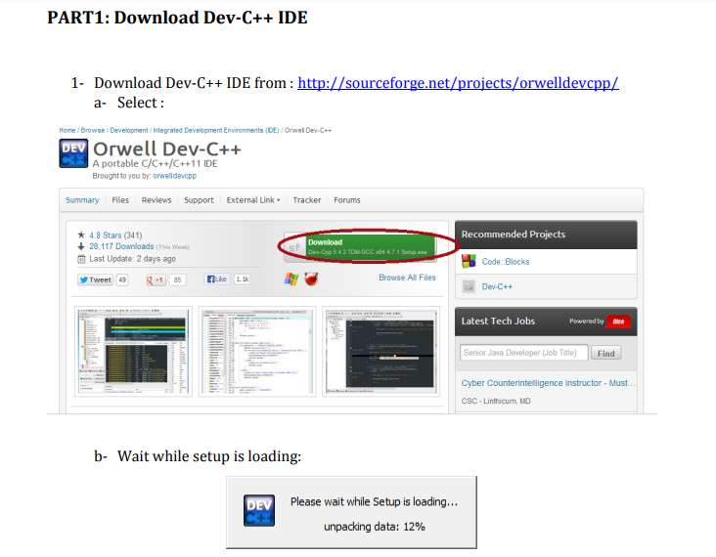

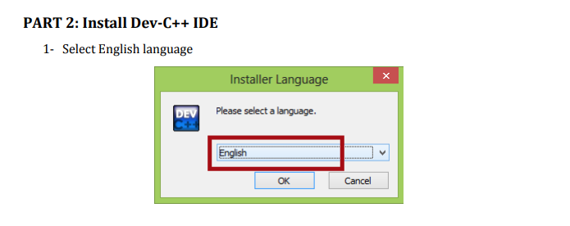
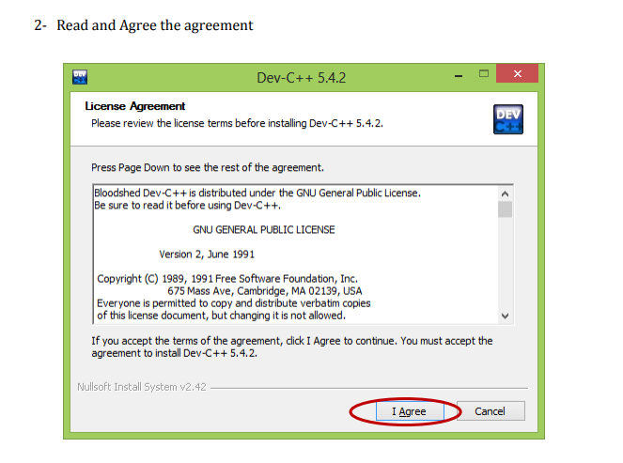
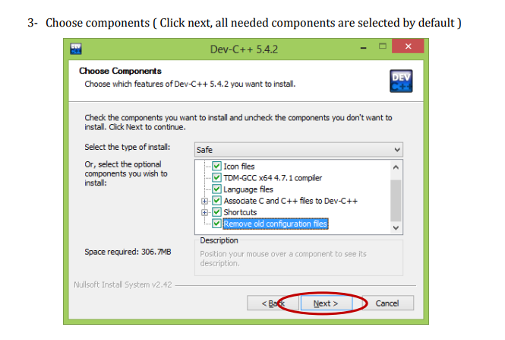
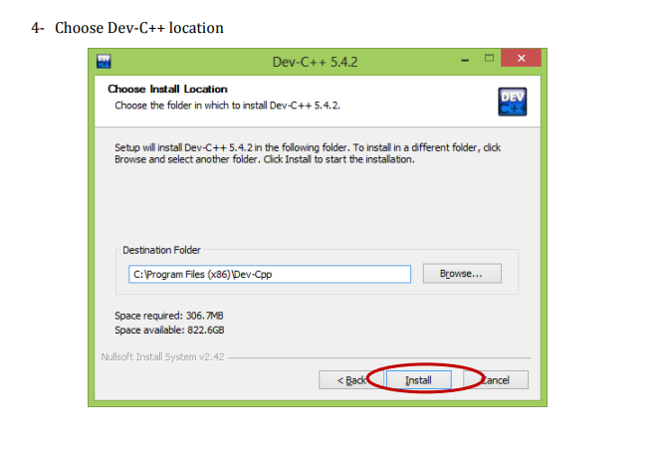
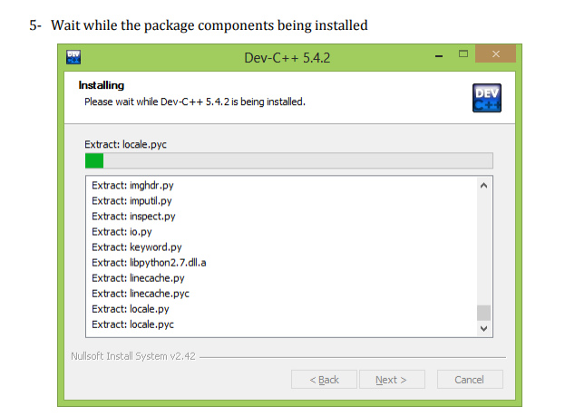
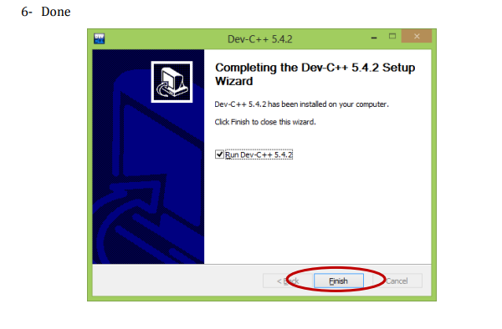
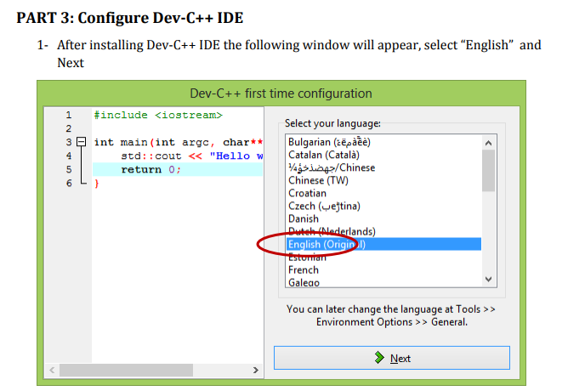
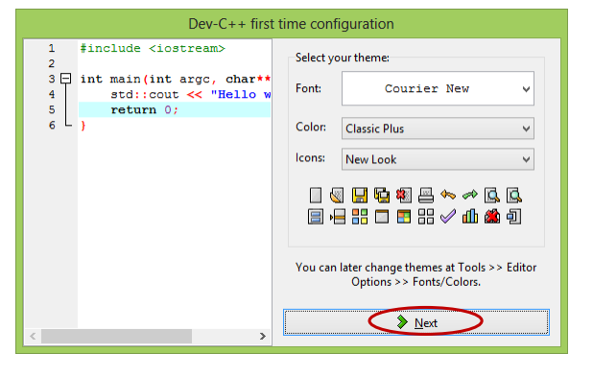
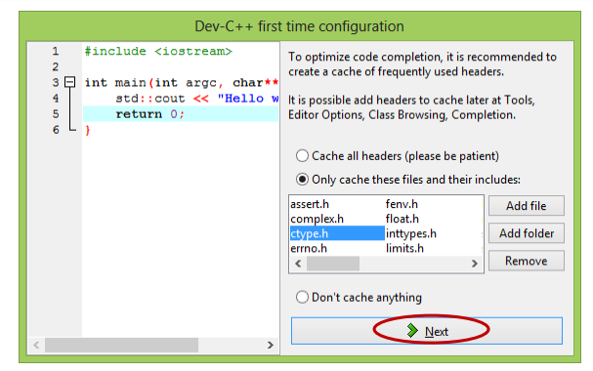
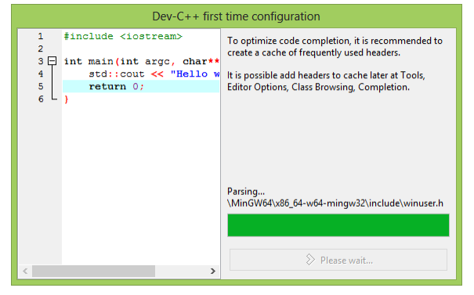
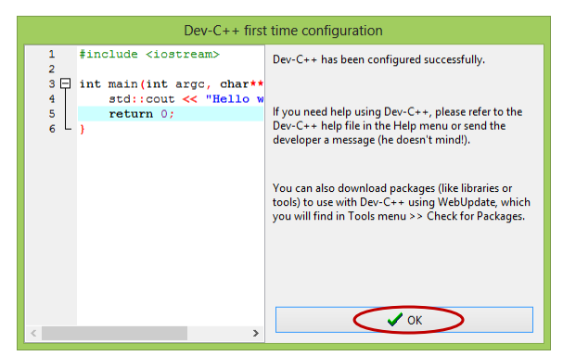
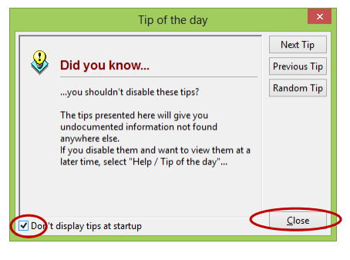
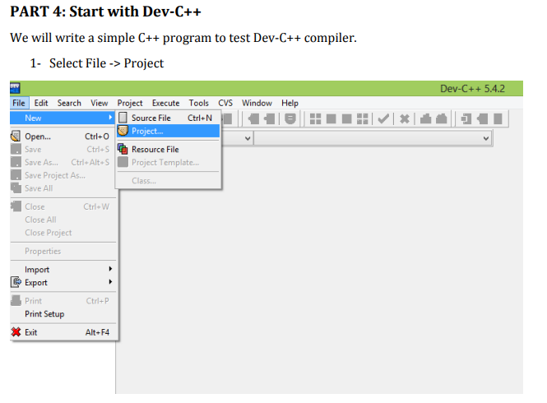
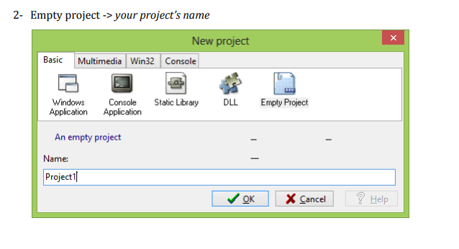
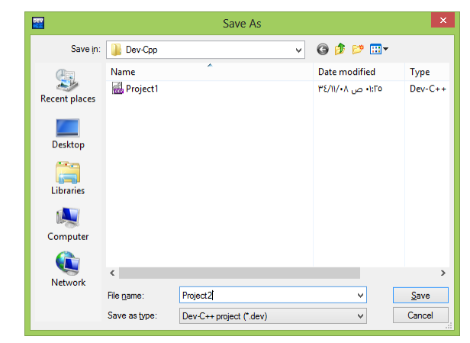
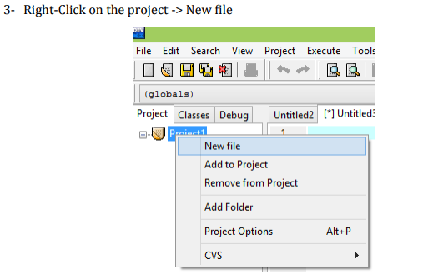
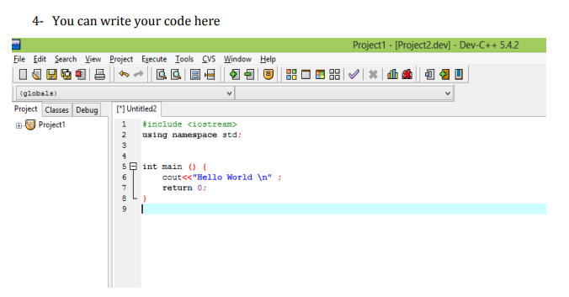
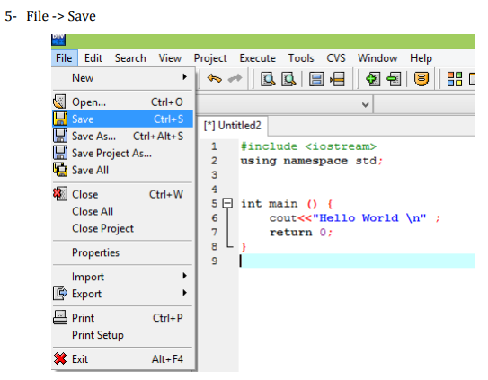
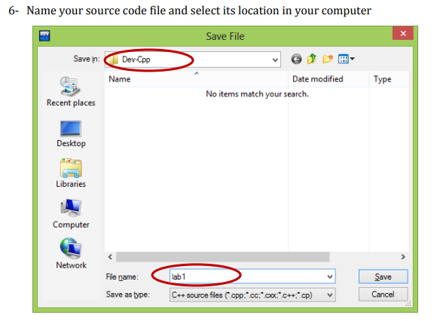
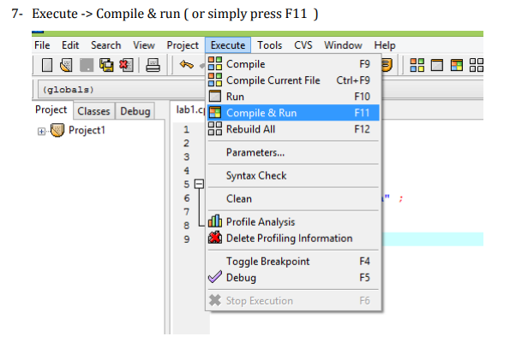
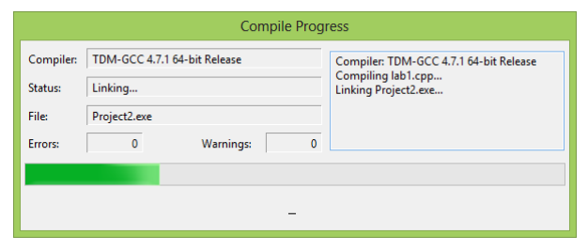
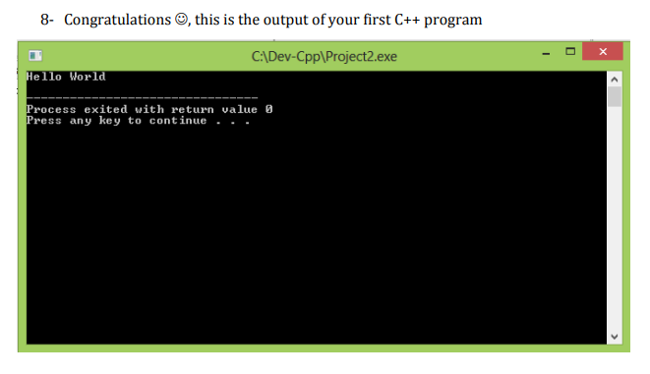

10. Dev c++ SHORTCUTS KEYS :
You can learn all shortcut keys by using this link :

https://hotkeycheatsheet.com/en/hotkey-cheatsheet/dev-c

Student’s task:

- Install Dev c++ on their laptops following the provided installation instructions & take a screenshot as proof of their successful setup execution.
- Create a new C++ source file and copy/paste given code & take screenshot of output.

#include<iostream>
using namespace std;

int main()
{
cout<<"hello world";

}
- Make the following changes to the program. What Errors are observed?
- Write Cout instead of cout.
- Remove semicolon; (any one)
- Erase any one of brace ‘{’ or ‘}’.

_________ __________________ _____________________
Date Lab Instructor Sign. Course Instructor Sign.

